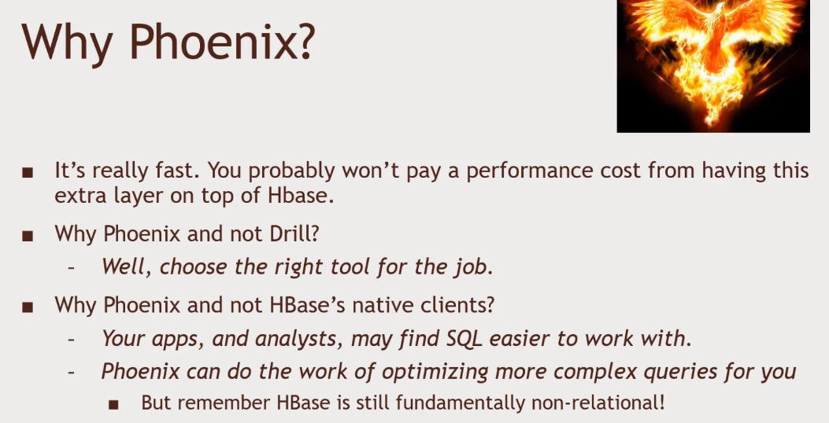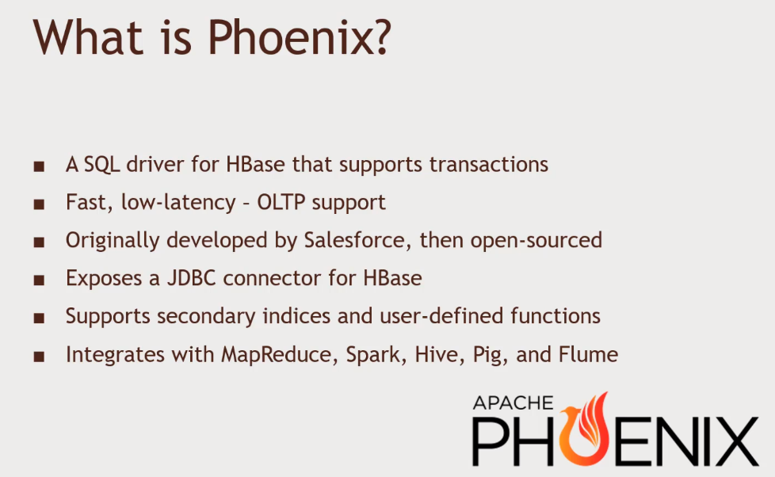Apache Phoneix -> SQL For HBase

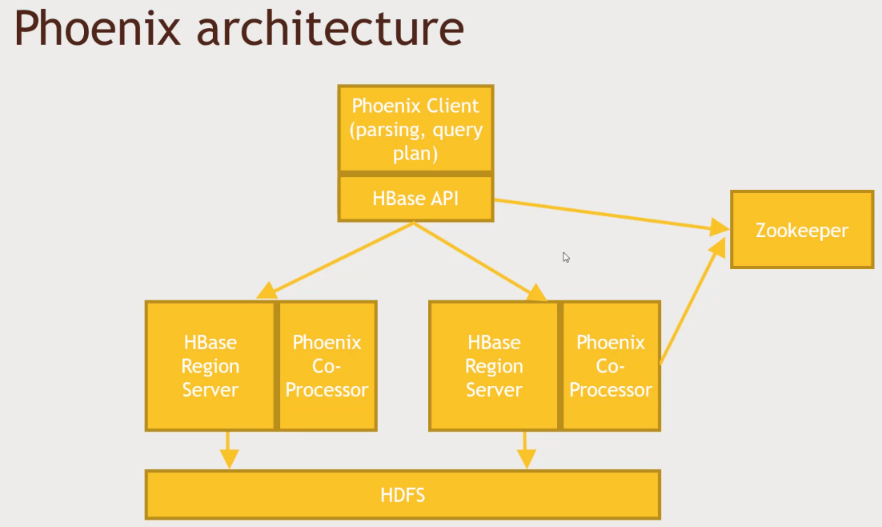Phoenix Architecture

Using Phoenix

* Command Line Interface
* Phoenix API for Java
* JDBC Driver (thick client)
* Phoenix Query Server (PQS) think client
  + Intended to eventually enable non-JVM access
* JAR’s for MapReduce, Hive, Pig, Flume, Spark

Install Phoenix

1. Horton Works Sandbox and ensure that HBase is running
   1. Login as Admin
   2. HBase -> Service Actions -> Start
   3. Login in to Putty.
2. HDP 2.6.5, Phoenix is already included.
   1. Cd /usr/hdp/current/phoenix-client
   2. 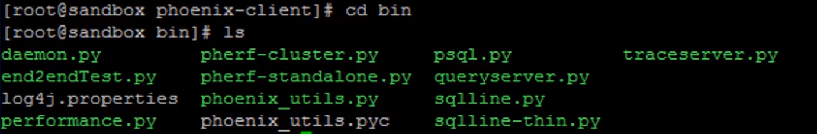See the bin folder
   3. Kick off phoenix, by typing python sqlline.py
   4. See the tables -> !tables under Phoenix
   5. Creating table -> CREATE TABLE IF NOT EXISTS us_population(  
      state CHAR (2) NOT NULL,  
      city VARCHAR NOT NULL,  
      population BIGINT  
      CONSTRAINT my_pk PRIMARY KEY (state,city))
   6. 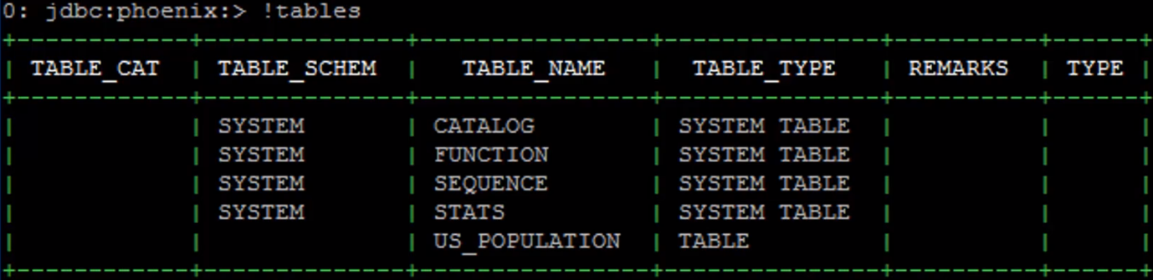!tables (you will see US_Population Table)
3. INSERT in SQL is known as UPSERT
   1. UPSERT INTO US_POPULATION VALUES (‘NY’, ‘New York’, 8143197);
   2. UPSERT INTO US_POPULATION VALUES (‘CA’, ‘Los Angeles’, 3844829);
   3. SELECT * FROM US_POPULATION;
   4. SELECT * FROM US_POPULATION WHERE STATE = ’CA’;
4. CLEAN UP
   1. DROP TABLE US_POPULATION;
   2. !quit